6.0 SAFEGUARDING AND CHILD PROTECTION POLICY

RUNNYMEDE PRE-SCHOOL EARLY YEARS PROVIDER

APPROVED BY: CATHERINE VICKERS

DATE: 10/09/2026

POLICY REVIEW DATE: 10/10/2027

Designated Safeguarding Lead (DSL) | CATHERINE VICKERS
Deputy Designated Safeguarding Lead (DDSL) | SARAH DEBENHAM



ADAPTED FOR RUNNYMEDE PRE-SCHOOL BY CATHERINE VICKERS
CONTENTS

1 | Introduction
2 | Statutory Framework
3 | Roles and responsibilities
4 | Types of abuse / specific safeguarding issues
5 | Children potentially at greater risk of harm
6 | Procedures
7 | Working with other partners to keep children safe
8 | Training
9 | Information sharing and confidentiality
10 | Child protection records
11 | Allegations about members of the workforce
12 | Physical intervention and use of reasonable force
13 | Whistleblowing
14 | Online safety
15 | Use of mobile phones
16 | Use of cameras, photography and images
17 | Attendance
Appendix A | Children and Families Service Map and Key Contacts
Appendix B | Essex Windscreen of Need and levels of intervention
Appendix C | Signs and symptoms of abuse

1. Introduction

‘Every child deserves the best possible start in life and the support that enables them to fulfil their potential.

Children learn best when they are healthy, safe and secure, when their individual needs are met, and when they have positive relationships with the adults caring for them.’

Statutory Framework for Early Years Foundation Stage (DfE, 2026)

This policy is for Management Committee, staff, parents / carers, volunteers, and the wider setting community. It forms part of the safeguarding arrangements for our setting and should be read in conjunction with the following:

- Statutory framework for the early years foundation stage (DfE, 2026);
- our Behaviour Policy, and:
- our Staff Code of Conduct
- our Attendance Policy

Safeguarding and promoting the welfare of children (everyone under the age of 18) is defined in Keeping children safe in education (DfE, 2026), as:

- Providing help and support to meet the needs of children as soon as problems emerge
- protecting children from maltreatment, whether that is within or outside the
home, including online
- preventing the impairment of children’s mental and physical health or development
- ensuring that children grow up in circumstances consistent with the provision of safe and effective care
- taking action to enable all children to have the best outcomes

We follow a whole-setting approach to safeguarding, which ensures that keeping children safe is at the heart of everything we do, and underpins all systems, processes, and policies. It is important that our values are understood and shared by all children, staff, parents / carers, volunteers, and the wider setting community. Only by working in partnership, can we truly keep children safe.

Early Years providers must take all necessary steps to keep children safe and well by:

- Safeguarding children
- Ensuring the people who have contact with children are suitable
- Promoting good health
- Supporting and understanding behaviour
- Maintaining records, policies, and procedures

2. Statutory framework
There is government guidance set out in Working Together (DfE, 2026) on how agencies must work in partnership to keep children safe. This guidance places a shared and equal duty on three Safeguarding Partners (the Local Authority, Police and Health) to work together to safeguard and promote the welfare of all children in their area under multi-agency safeguarding arrangements. These arrangements sit under the Essex Safeguarding Children Board (ESCB). In Essex, the statutory partners are Essex County Council, Essex Police, and three NHS Integrated Care Boards covering the county.

Early years settings have a duty under section 40 of the Childcare Act 2006 to comply with the safeguarding and welfare requirements of the Early Years Foundation Stage, under which settings are required to take necessary steps to safeguard and promote the welfare of young children.

In addition to national statutory guidance, in Essex, all professionals must work in accordance with the SET Procedures.

Our setting also works in accordance with the following legislation and guidance (this is not an exhaustive list):

- Statutory framework for the early years foundation stage (DfE, 2026)
- Working Together (DfE, 2026)
- What to do if you’re worried a child is being abused (HMG, 2015)
- The Prevent Duty guidance (Home Office, 2015)
- Effective Support for Children and Families in Essex (ESCB 2026)
- Understanding and supporting behaviour - Safe practice for schools (Essex County Council)
- Children Act (HMG, 1989)
- Children Act (HMG, 2004)
- Childcare Act (HMG, 2006)
- Children and Social Work Act ( HMG, 2017)
- Keeping children safe in education (DfE, 2026)
- Counter-Terrorism and Security Act (HMG, 2015)
- Help for early years providers: Screen use (DFE 2026)

3. Roles and responsibilities
All adults working with or on behalf of children have a responsibility to protect them and to provide a safe environment in which they can learn and achieve their full potential. However, there are key people within settings and the Local Authority who have specific responsibilities under child protection procedures. The names of those in our setting with these specific responsibilities (the Designated Safeguarding Lead and Deputy Designated Safeguarding Lead) are shown on the cover sheet of this document. However, we are clear that safeguarding is everyone’s responsibility and that everyone who comes into contact with children has a role to play.
The management committee
- The management committee has strategic oversight of our safeguarding arrangements. It ensures that these arrangements operate effectively, as follows: we have appropriate policies in place;
- our staff receive the right training to keep children safe, including regular safeguarding and child protection updates, at least annually, to provide them with the relevant skills and knowledge to keep our children safe;
- we have a named Designated Safeguarding Lead (DSL) who takes lead responsibility for safeguarding children, and a deputy (DDSL) to provide cover when the DSL is absent (their names are on the front page of this policy);
- all adults in our setting who work with children undergo safeguarding and child protection training at induction as appropriate, which is regularly updated;
- our setting contributes to inter-agency working, in line with statutory and local guidance;
- information is shared and stored appropriately and in accordance with statutory requirements;
- we have safer recruitment and selection procedures in place that help to deter, reject, or identify people who might abuse children;
- we meet statutory responsibilities to check adults working with children;
- we ensure all staff, students and volunteers are subject to appropriate recruitment, vetting and suitability checks in line with EYFS requirements, including enhanced DBS and barred list checks where required
- individuals do not commence work or volunteering until appropriate checks have been completed
- we ensure staff are aware of their duty to disclose any information that may affect their suitability to work with children, including arrests, charges, cautions, convictions, court orders or other relevant matters

The Designated Safeguarding Lead (DSL)
Our DSL is responsible for liaison with local statutory children's services agencies, including Essex Social Care and other agencies as required. The DSL provides support, advice, and guidance to staff on an ongoing basis, and on any specific safeguarding issues as required.
Our DSL and deputy (DDSL) attend child protection training to enable them to identify, understand and respond appropriately to signs of possible abuse and neglect. This is undertaken at least every two years (in line with statutory requirements) and they will access other appropriate training alongside this to ensure they have the appropriate knowledge and understanding to carry out their role.

The DSL also ensures that everyone in our setting (including temporary staff, volunteers, visitors, and contractors) is aware of our child protection procedures and that they are followed at all times. They also ensure that all staff receive appropriate safeguarding training (in line with Annex C: criteria for effective safeguarding training) and that they are supported to implement safeguarding policies effectively in practice.

All staff
Everyone in our setting has a responsibility to provide a safe environment in which our children can learn. We recognise that any child may benefit from early help and all our staff members are aware of the Essex Early Help procedures and our role in it. They are aware of signs of abuse and neglect so they are able to identify children who may need help or protection.

All staff members are aware of and follow our procedures (as set out in this policy) and are aware of how to make a request for support to Essex Social Care if there is a need to do so. Staff understand that, if they have any concerns about a child’s welfare, they must act on them immediately and speak with the DSL or DDSL – they do not assume that others have taken action.

Our staff understand that children may not always feel able or know how to tell someone that they are being abused, perhaps due to their age, or because they are embarrassed, or they may not always recognise that they are being abused. We recognise there are many factors which may impact on our children’s welfare and safety and we understand safeguarding in the wider context (contextual safeguarding). We also understand that abuse, neglect, and safeguarding issues are rarely ‘stand-alone’ events and that, in most cases, multiple issues will overlap.

Our staff will always reassure children who report abuse / victims of abuse that they are taken seriously and that they will be supported and kept safe. We will never make a child feel ashamed for reporting abuse, nor make them feel they are causing a problem.

4. Types of abuse / specific safeguarding issues
Information about abuse and harm including examples of specific safeguarding issues is set out below. Further information about types of abuse and harm is given in:

- What to do if you’re worried a child is being abused: Advice for practitioners (HMG, 2015); and

- Keeping Children Safe in Education (DfE, 2026)

Keeping Children Safe in Education describes abuse as ‘a form of maltreatment of a child’. It sets out that:
“Somebody may abuse or neglect a child by inflicting harm or by failing to act to prevent harm. Harm can include ill treatment that is not physical as well as the impact of witnessing ill treatment of others… Children may be abused in a family or in an institutional or community setting by those known to them or, more rarely, by others. Abuse can take place wholly online, or technology may be
used to facilitate offline abuse. Children may be abused by an adult or adults or by another child or children. Children may also cause harm to other family members, often referred to as child to parent or care giver abuse.”

The guidance refers to four main categories of abuse:

- Physical - may involve hitting, shaking, throwing, poisoning, burning or scalding, drowning, suffocating or otherwise causing physical harm to a child. Physical harm may also be caused when a parent / carer fabricates the symptoms of, or deliberately induces, illness in a child

- Emotional - the persistent emotional maltreatment of a child such as to cause severe and adverse effects on the child’s emotional development

- Sexual - forcing or enticing a child or young person to take part in sexual activities, not necessarily involving violence, whether or not the child is aware of what is happening. Sexual abuse can take place online, and technology can be used to facilitate offline abuse. Sexual abuse is not solely perpetrated by adult males. Women can also commit acts of sexual abuse, as can other children

- Neglect - persistent failure to meet a child’s basic physical and/or psychological needs, likely to result in the serious impairment of the child’s health or development

Child-on-child abuse, including harmful sexual behaviour
Child on child abuse can manifest itself in many ways and may occur in person and / or online. We do not tolerate harmful behaviour of any kind in our setting and will take swift action to intervene where this occurs, challenging inappropriate behaviours when they occur to prevent them from escalating. We do not normalise harmful behaviour or abuse, and it is not tolerated in our setting. Our culture is very much one of kindness, compassion, hope, connection and belonging.

Any incidents of child-on-child abuse will be managed in the same way as any other child protection concern, and we will follow the same procedures. We will seek advice and support from other agencies as necessary and ensure that appropriate agencies are involved when required.

Our setting recognises that some children may abuse other children and that this may happen in our setting or outside of it. We understand there are many reasons why a child may display harmful behaviours towards other children, and that these matters are sensitive and often complex. We recognise our setting may be the only stable, secure and safe element in the lives of some children, particularly those who have experienced harm and trauma. We have a duty to safeguard all children and, whilst inappropriate behaviours will be challenged and addressed, it is always considered in the context of providing appropriate support to all children where harmful behaviour has occurred. We will always take a balanced and proportionate approach to risky or harmful behaviour.

We understand the barriers which may prevent a child from reporting abuse and work actively to remove these. We support children to learn about healthy, positive relationships, how to report concerns, and to help them understand, in an age-appropriate way, what abuse is. We aim to provide children with the language to report abuse and to tell a trusted adult if someone is behaving in a way that makes them feel uncomfortable. We will never make a child feel ashamed for reporting abuse, nor that they are creating a problem by doing so. We never assume, if abuse is not being reported, that it is not occurring in our setting – we are vigilant to signs of abuse and promote a culture of safety and understanding.

It is normal for some children to display sexualised behaviour towards other children as they develop. However, harmful sexual behaviour (HSB) is developmentally inappropriate sexual behaviour which is displayed by children, and which may be harmful or abusive. It may also be referred to as sexually harmful behaviour or sexualised behaviour. HSB encompasses a range of behaviour, which can be displayed towards younger children, peers, older children, or adults. It is harmful to the children and young people who display it, as well as those it is directed towards.

We understand that, if a child's sexual behaviour is not developmentally appropriate or expected for their age, it is important to respond quickly, before the behaviour becomes harmful to that child or other children. We recognise HSB may also be a sign that a child has suffered their own trauma or abuse, and we will respond to ensure they receive the right help at the right time to address the concerning behaviour.

Domestic abuse
Domestic abuse can involve a wide range of behaviours and may be a single or multiple / ongoing incidents. It can include intimate partner violence, abuse by family members, teenage relationship abuse and child to parent abuse. We understand that anyone can be a victim of domestic abuse, and that it can take place inside or outside of the home.

Our setting recognises that exposure to domestic abuse (either by witnessing or experiencing it) can have a serious, long-term emotional and psychological impact on children. We work with other key partners, and we receive and share relevant information where there are concerns that domestic abuse may be an issue for a child or family or be placing a child at risk of harm.

In Essex, the Southend, Essex and Thurrock Domestic Abuse Board (SETDAB) is responsible for designing and implementing the Domestic Abuse Strategy and provides advice, guidance and resources to support work around domestic abuse.

Risk in the community (RIC)
Risk in the community is the Essex partnership approach to tackling criminal and sexual exploitation of children and young people.

We understand that safeguarding incidents and behaviours can be associated with factors in the community, outside a child’s home or our school. All staff are aware of ‘contextual safeguarding’ and we are therefore mindful of things in a child’s life which may be a threat to their safety and / or welfare. We always consider relevant information when assessing any risk to a child and will share it with other agencies when appropriate, to support better understanding of a child and their family. This is to ensure that our children and families receive the right help at the right time and to help keep our children safe.

Risk in the community
We understand that safeguarding incidents and behaviours can be associated with factors outside a child’s home or our setting, and that there are risks that exist in the community. All staff are aware of contextual safeguarding and we are therefore mindful of whether wider environmental factors present in a child’s life are a threat to their safety and / or welfare. We always consider relevant information when assessing any risk to a child and will share it with other agencies when appropriate, to support better understanding of a child and their family. This is to ensure that our children and families receive the right help at the right time.

Emotional wellbeing
Children’s personal, social, and emotional development (PSED) is crucial for them to lead healthy and happy lives and is fundamental to their cognitive development. We understand that a child’s positive wellbeing is vital and that poor wellbeing can, in some cases, be an indicator that a child has suffered or is at risk of suffering abuse, neglect or exploitation. We recognise that where children have suffered abuse or other potentially traumatic adverse childhood experiences, this can have a lasting impact throughout childhood, adolescence and into adulthood.

It is vital that we work in partnership with parents/carers to support the wellbeing of our children. We expect parents/carers, if they have any concerns about the wellbeing of their child, to share this with us, so we can ensure that appropriate support and interventions can be identified and implemented.

Prevention of radicalisation
Children can be vulnerable to radicalisation and extremism in the same way they are vulnerable to other safeguarding issues. Keeping Children Safe in Education (DfE, 2026) defines the following:

Extremism: the vocal or active opposition to our fundamental values, including democracy, the rule of law, individual liberty and the mutual respect and tolerance of different faiths and beliefs. This also includes calling for the death of members of the armed forces

Radicalisation: refers to the process by which a person comes to support terrorism and extremist ideologies associated with terrorist groups

Terrorism: an action that endangers or causes serious violence to a person/people; causes serious damage to property; or seriously interferes or disrupts an electronic system. The use or threat must be designed to influence the government or to intimidate the public and is made for the purpose of advancing a political, religious, or ideological cause.

The Counter-Terrorism and Security Act (HMG, 2015) placed a duty on childcare providers and schools. Under section 26 of the Act, childcare providers and schools are required, in the exercise of their functions, to have ‘due regard to the need to prevent people from being drawn into terrorism’. This duty is known as the Prevent Duty.

Channel is a national programme which focuses on providing support at an early stage to people identified as vulnerable to being drawn into terrorism. Prevent referrals may be passed to a multi-agency Channel panel, which will discuss the individual referred to determine whether they are vulnerable to being drawn into terrorism and consider the appropriate support required. A representative from an educational setting may be asked to attend the Channel panel to help with this assessment. An individual’s engagement with the programme is entirely voluntary at all stages.

Honour or faith-based abuse (including Female Genital Mutilation and forced marriage)
Honour or faith-based abuse (HBA) encompasses incidents or crimes which have been committed to protect or defend the honour of the family and/or the community, including female genital mutilation (FGM), forced marriage, and practices such as breast ironing. We understand that this form of abuse often involves a wider network of family or community pressure and can include multiple perpetrators.

Female Genital Mutilation (FGM) comprises all procedures involving partial or total removal of the external female genitalia or other injury to female genital organs. It is illegal in the UK and a form of child abuse.

The Serious Crime Act 2015 (Home Office, 2015) introduced a duty on teachers (and other professionals) to notify the police of known cases of FGM where it appears to have been carried out on a girl under the age of 18. Our setting operates in accordance with the statutory requirements relating to this issue, and in line with local safeguarding procedures.

A forced marriage is one entered into without the full consent of one or both parties. It is where violence, threats or other forms of coercion is used and is a crime. We will always report any concerns that a child may be or has been subjected to a forced marriage and will work with the appropriate agencies.
Prevention of radicalisation
Children can be vulnerable to radicalisation and extremism in the same way they are vulnerable to other safeguarding issues. Keeping Children Safe in Education (DfE, 2025) defines the following:

Extremism: the vocal or active opposition to our fundamental values, including democracy, the rule of law, individual liberty and the mutual respect and tolerance of different faiths and beliefs. This also includes calling for the death of members of the armed forces
Radicalisation: refers to the process by which a person comes to support terrorism and extremist ideologies associated with terrorist groups

Terrorism: an action that endangers or causes serious violence to a person/people; causes serious damage to property; or seriously interferes or disrupts an electronic system. The use or threat must be designed to influence the government or to intimidate the public and is made for the purpose of advancing a political, religious, or ideological cause.

The Counter-Terrorism and Security Act (HMG, 2015) placed a duty on childcare providers and schools. Under section 26 of the Act, childcare providers and schools are required, in the exercise of their functions, to have ‘due regard to the need to prevent people from being drawn into terrorism’. This duty is known as the Prevent Duty.

Channel is a national programme which focuses on providing support at an early stage to people identified as vulnerable to being drawn into terrorism. Prevent referrals may be passed to a multi-agency Channel panel, which will discuss the individual referred to determine whether they are vulnerable to being drawn into terrorism and consider the appropriate support required. A representative from an educational setting may be asked to attend the Channel panel to help with this assessment. An individual’s engagement with the programme is entirely voluntary at all stages.

5. Children potentially at greater risk of harm
We recognise that some children may potentially be at risk of greater harm and require additional help and support. These may be:

- children with a Child in Need or Child Protection Plan, those in Care or previously in Care
- children with special educational needs, disabilities or health issues
- children requiring support with mental health
- children with parents in need of support
- children with medical needs

Our setting understands that children with special educational needs (SEN) and / or disabilities can face additional safeguarding challenges and that barriers can exist when recognising abuse and neglect for these children. These can include:

- that indicators of possible abuse such as behaviour, mood and injury relate to the child’s disability
- that they may be more prone to peer group isolation than others
- that they may be disproportionally impacted by things like bullying, without outwardly showing signs
- potential communication difficulties in managing or reporting abuse or recognising that abuse is occurring
- potential additional risks due to higher dependency on adults and / or need for intimate care
- issues with understanding the risks online and how it may influence their behaviour
We work with Social Care and other relevant agencies to ensure there is a joined-up approach to planning for all children and that they receive the appropriate help and support.

6. Procedures
Our setting works with key local partners to promote the welfare of children and protect them from harm. This includes providing a co-ordinated offer of early help when additional needs of children are identified and contributing to inter-agency plans which provide additional support (through a Child In Need or a Child Protection plan).

All staff members have a duty to identify and respond to suspected / actual abuse or disclosures of abuse. Any member of staff, volunteer or visitor to the setting who receives a disclosure or allegation of abuse, or suspects that abuse may have occurred, must report it immediately to the DSL (or, in their absence, the DDSL).

All action is taken in accordance with the following guidance:

- Statutory framework for the early years foundation stage (DfE, 2026)
- Keeping Children Safe in Education (DfE, 2026)
- Working Together to Safeguard Children (DfE, 2026)
- Essex Safeguarding Children Board guidelines - the SET (Southend, Essex and Thurrock) Child Protection Procedures (ESCB, 2026)
- ‘Effective Support for Children and Families in Essex’ (ESCB)
- PREVENT Duty - Counter-Terrorism and Security Act (HMG, 2015)

Where there is risk of immediate harm, concerns will be referred by telephone to the Children and Families Hub and / or the Police. Less urgent concerns or requests for support will be sent to the Children and Families Hub via Essex Effective Support . The setting may also seek advice from Essex Social Care or another appropriate agency about a concern if we are unsure how to respond to it.

Wherever possible, we will share any safeguarding concerns, or an intention to refer a child to Children’s Social Care, with parents / carers. However, we will not do so where it is felt that to do so could place a child at greater risk of harm or impede a criminal investigation, or where we are advised not to. If it is necessary for another agency to meet with a child in the setting, we will always seek to inform parents or carers, unless we are advised not to by that agency. On occasions, it may be necessary to consult with the Children and Families Hub and / or Essex Police for advice on when to share information with parents / carers.

All staff understand that, if they continue to have concerns about a child, or feel a concern is not being addressed or does not appear to be improving, they should press for re-consideration of the case with the DSL.

If, for any reason, the DSL or DDSL is not immediately available, this will not delay any appropriate action being taken. Safeguarding contact details are displayed in our setting to ensure that all staff members have access to urgent safeguarding support, should it be required. Any individual may refer to Social Care where there is suspected or actual risk of harm to a child.
When new staff, volunteers or regular visitors join our setting they are informed of the safeguarding arrangements in place, the name of the DSL and DDSL and how to share concerns with them.

7. Working with other partners to keep children safe
It is the responsibility of the DSL to ensure our setting is represented at, and that a report is submitted to, any statutory meeting called for children currently at our setting or previously known to us. Where possible and appropriate, any report will be shared in advance with parent(s) / carer(s). The member of staff attending the meeting will be fully briefed on any issues or concerns the setting has and be prepared to contribute to the discussions.

If a child is subject to a Care, Child Protection or a Child in Need plan, the DSL will ensure the child is monitored regarding their attendance, emotional wellbeing, EYFS progress, welfare, and presentation. If the setting is part of the core group, the DSL will ensure the setting is represented, provides appropriate information, and contributes to the plan at these meetings. Any concerns about a plan and / or the child’s welfare will be discussed and recorded at the core group meeting, unless to do so would place the child at further risk of significant harm. In this case the DSL will inform the child’s key worker immediately and then record that they have done so and the actions agreed.

8. Training
The DSL and DDSL undertake Level 3 safeguarding training at least every two years. The Manager and all staff receive appropriate safeguarding training at least annually, in line with ESCB expectations.

In addition, all staff and other adults working with children in our setting receive safeguarding and child protection updates as required, but at least annually, to provide them with relevant skills and knowledge to safeguard children effectively. Records of any child protection training undertaken are kept for all staff.

9. Information sharing and confidentiality
Sharing information is a key part of safeguarding work and decisions about how much information to share, with whom and when, can have a profound impact on a child’s life. Effective information sharing can help to ensure that a child receives the right help at the right time and can prevent a concern from becoming more serious and difficult to address.

Where there are concerns about the safety of a child, the sharing of information in a timely and effective manner between organisations can reduce the risk of harm. Whilst the Data Protection Act 2018 places duties on organisations and individuals to process personal information fairly and lawfully, it is not a barrier to sharing information, where the failure to do so would result in a child or vulnerable adult being placed at risk of harm. Similarly, human rights concerns, such as respecting the right to a private and family life, would not prevent sharing information where there are real safeguarding concerns. Fears about sharing information cannot (and will not) stand in the way of the need to safeguard and promote the welfare of children at risk of abuse or neglect.

Our staff will never guarantee confidentiality to anyone (including parents / carers, or children) about a safeguarding concern, nor promise to keep a secret. In accordance with statutory requirements, where there is a child protection concern, this must be reported to the DSL or DDSL and may require further referral to and subsequent investigation by appropriate authorities.

Information on individual child protection cases may be shared by the DSL or DDSL with other relevant staff members. This will be on a ‘need to know’ basis only and where it is in the child’s best interests to do so.

Where a child is attending another setting at the same time as attending ours we may, where appropriate, link with the other setting. Wherever possible, we will inform parents / carers of our intention to do this, unless to do so would place the child at further risk.

10. Child protection records
Well-kept records are essential to good child protection practice. Our setting is clear about the need to record any concern held about a child or children within our setting and when these records should be shared with other agencies.

Any member of staff receiving a disclosure of abuse or noticing signs or indicators of abuse will record it as soon as possible, noting what was said or seen (if appropriate, using a body map to record), giving the date, time, and location. All records will be dated and signed and will include the action taken. This is then presented to the DSL or DDSL, who will decide on appropriate action and record this accordingly.

Any records relating to child protection are kept on an individual child protection file for that child (which is separate to any other child file). All child protection records are stored securely and confidentially until the child transfers to another educational setting.

Where a child transfers from our setting to another setting or school, their child protection records will be forwarded to the new educational setting. These will be marked ‘Confidential’ and for the attention of the DSL at the new setting, with a return address on the envelope so it can be returned to us if it goes astray. We will obtain evidence that the paperwork has been received by the new setting, and then destroy any copies held in our setting. Where appropriate, the DSL may also contact the new setting in advance of the child’s move there, to enable planning so appropriate support is in place when the child arrives.

Where a child joins our setting, we will request child protection records from the previous educational setting (if applicable, and if none are received).

Where a child is attending another setting at the same time as ours, we will share any child protection records where appropriate and where it is in the best interests of the child. We will link with other settings when there is a need to so and we will be transparent with parents when we do so (unless to do so would place a child at further risk of harm).

11.​ Allegations about members of the children’s workforce
We ensure all staff members (including agency staff) are made aware of the boundaries of appropriate behaviour and conduct. These matters form part of staff induction and are outlined in our Staff Behaviour policy / Code of Conduct. All staff are regularly reminded of this through updates and training, and are also informed about our Whistleblowing Policy.

Keeping Children Safe in Education (DfE 2026) and the SET procedures (ESCB 2026) set out the procedures in respect of allegations against an adult working with children (in a paid or voluntary capacity). These procedures should be followed where an adult has:

- behaved in a way that has harmed a child, or may have harmed a child and/or
- possibly committed a criminal offence against or related to a child, and/or
- behaved towards a child or children in a way that indicates he or she may pose a risk of harm to children, and/or
- behaved or may have behaved in a way that indicates they may not be suitable to work with children

Any concerns about an adult in our setting should be reported to the Manager or the Deputy Manager, who will then decide how to take this forward. In some cases, it might not be clear whether an incident constitutes an allegation. If this is the case, it will be necessary for us to explore the concerns to establish some facts – this initial fact-finding is not an investigation, it is to clarify information and to direct our response to the concern raised.

Where an allegation against an adult in our setting is received, and it is felt that any of the above criteria apply, the SET procedures (ESCB, 2025) require this to be reported to the Duty Local Authority Designated Officer (LADO) at the Essex Workforce Allegations Team at LADO@essex.gov.uk. This should be done by the Manager or Deputy Manager within one working day (or sooner via 03330 139797 if immediate safeguarding is required). Where the concern is about the Manager, it should be reported direct to the Chairperson. In the event of an allegation relating to the conduct and behaviour of an agency member of staff, the LADO will liaise with the agency, while following due process, to facilitate a joint investigation or enable the agency to move this forward.

In accordance with the Statutory framework for the early years foundation stage (DfE, 2026), we will also inform Ofsted of any allegations of serious harm or abuse by any person living, working, or looking after children at the premises (whether the allegations relate to harm or abuse committed on the premises or elsewhere). We will also notify Ofsted of the action taken in respect of the allegations. We will make these notifications as soon as reasonably practicable, but within 14 days of the allegations being made. We are aware that not complying with these requirements without reasonable excuse is committing an offence.

Staffing matters are confidential and the setting operates within a statutory framework around Data Protection. We do not share information about any individual staff member with anyone other than any appropriate statutory agency.

12.​ Physical intervention and use of reasonable force
Our Behaviour Policy sets out our approach to behaviour for all children and also for those with more challenging or harmful behaviour. We recognise there are some children who have needs that require additional support and a more personalised approach and we always consider all behaviour, and our response to it, in the context of safeguarding.

There are occasions when staff will need to have physical contact with children. These may include:

- to comfort a child in distress (appropriate to their age and individual specific needs identified through a risk assessment)
- to direct a child
- for curricular reasons (for example during physical activity, or when we are using music)
- in an emergency, to avert danger to the child or others

The term ‘reasonable force’ covers a broad range of actions used by staff that involve a degree of physical contact to control or restrain children. There are circumstances when it is appropriate for staff to use reasonable force to safeguard children, such as guiding a child to safety. ‘Reasonable’ means using no more force than is needed. Our setting works in accordance with statutory and local guidance on the use of reasonable force and recognises that where intervention is required, it should always be considered in a safeguarding context.

13. Whistleblowing
All members of staff and the wider setting community should be able to raise concerns about poor or unsafe practice and feel confident any concern will be taken seriously by the leadership team. We have ‘whistleblowing’ procedures in place and these are available in the setting Whistleblowing Policy. However, for any member of staff who feels unable to raise concerns internally, or where they feel their concerns have not been addressed, they may contact the NSPCC whistleblowing helpline on: 0800 028 0285 (line is available from 8:00 AM to 8:00 PM, Monday to Friday) or by email at: help@nspcc.org.uk.
Parents / carers or others in the wider setting community with concerns can contact the NSPCC general helpline on 0808 800 5000 (24-hour helpline) or email: help@nspcc.org.uk.

14. Online Safety
Technology forms part of the Early years foundation stage statutory framework; computer skills are key to accessing learning. All staff in our setting are aware of the risks to children online, and understand that any child can be vulnerable, and that their vulnerability can vary according to age, developmental stage, and personal circumstances. We help our children to begin to learn how to use technology safely, and to be safe online. We will engage with our parents / carers about online safety to support them in keeping their children safe at home when using technology. Children must be safeguarded from inappropriate and potentially harmful content online. We apply appropriate settings to all devices used by the children at our setting, and monitor and review this regularly. We will ensure that we refer to the guidance on children’s screen use as in early years settings Help for early years providers: Screen use (DfE 2026)

15. Use of mobile phones
We acknowledge that mobile phones are often the only means of contact available and can be helpful in supporting safeguarding arrangements in settings, including when on outings. In our setting, when mobile phones are used, this is underpinned by a risk assessment and operated within a clear framework, so everyone understands their responsibilities in ensuring phones are used safely.

We will ensure that staff personal mobiles:

- are stored in our office / kitchen with the staff’s personal belongings and bags and will be switched on silent whilst staff are on duty
- are not used to take pictures of any children attending the setting
- are not used to take photographs, video, or audio recordings in our setting
- are not used to contact parents / carers or children except in the event of an emergency
- are not used by visitors

16. Use of cameras, photography and images
Most people who take or view photographs or videos of children do so for acceptable reasons. However, due to cases of abuse to children through taking or using images, we must ensure that we have safeguards in place.

To keep our children safe, we will:

- always obtain consent from parents / carers for photographs or video recordings to be taken, used, or published (for example, on our website or displays)

- ensure only the setting’s designated cameras/tablets are used when photographing or videoing children;

- ensure that children are appropriately dressed if photographs or videos are to be taken;

- ensure that children’s names are not displayed alongside any photographs in a public space;

- ensure that personal devices including cameras, mobile phones, tablets, smart watches, or other such technology are not used to take photographs, video, or audio recordings in our setting without prior explicit written consent from the setting; Staff follow our E safety policy (6.7)

- ensure that all images are stored securely and in accordance with statutory guidance;

- ensure where professional photographers are used that the appropriate checks, such as those with the Disclosure and Barring Service, references and parental consent are obtained prior to photographs being taken.

17. Attendance
Whilst there is no legal requirement for children to attend a setting before the term after their fifth birthday, we understand the importance of good attendance at our setting as a protective factor and also to support the development and wellbeing of our children. Repeated and unexplained absence from the setting can be a concern for a number of reasons:
- it is a potential indicator of abuse or neglect
- it can significantly impact on a child’s progress and / or wellbeing
In accordance with our Absence and Attendance Policy ( 9.3 ) and as part of safeguarding and Health and Safety procedures, we keep a daily record of the names of the children being cared for on the premises and their hours of attendance. This data is used to identify patterns of absence as they emerge, to ensure any concerns are identified and addressed at an early stage. We also have procedures to follow up on absence from our setting and may work with other relevant agencies where it is appropriate to do so, or where we have concerns about a child.

Appendix A: Children and Families Flow chart

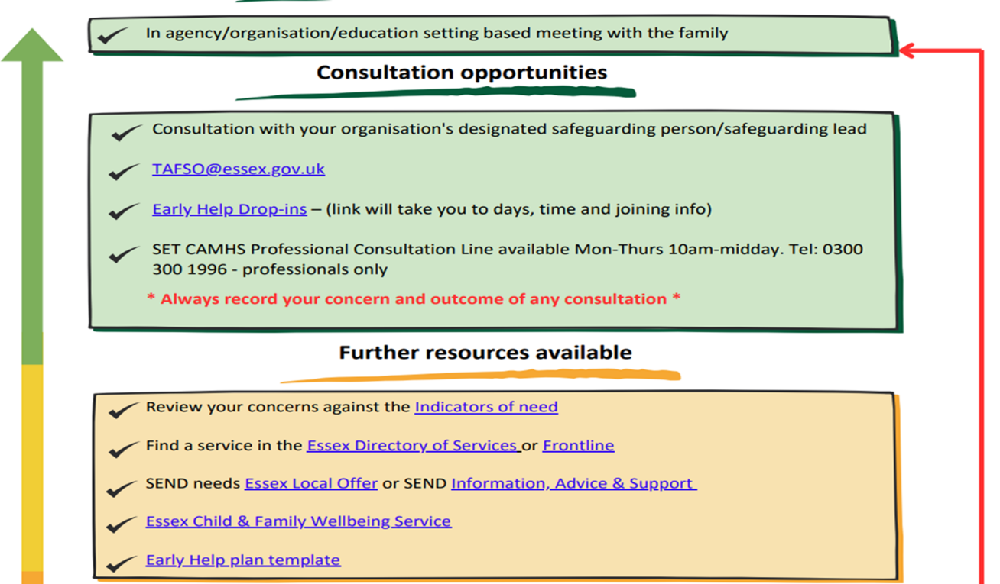

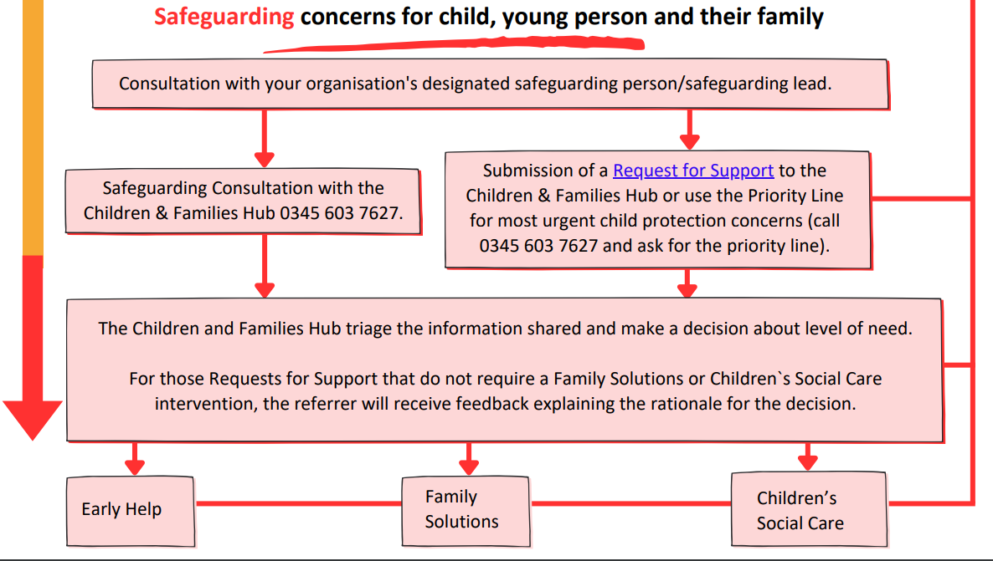

Appendix B
Windscreen of Need and levels of intervention

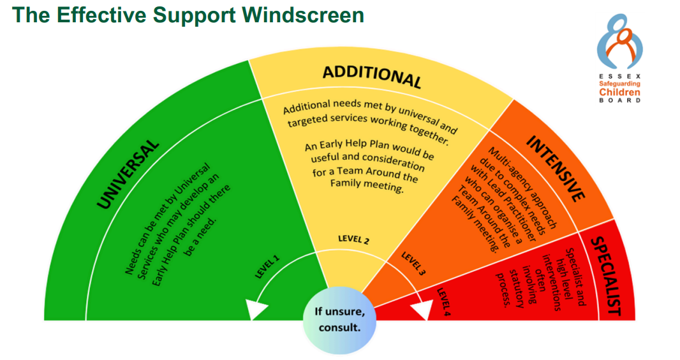

All partners working with children, young people and their families will offer support as soon as we are aware of any additional needs. We will always seek to work together to provide support to children, young people and their families at the lowest level possible in accordance with their needs

Children with Additional needs are best supported by those who already work with them, such as Family Hubs or schools and other educational settings, organising additional support with local partners as needed. When an agency is supporting these children, an Early Help Plan and a Lead Professional are helpful to share information and co-ordinate work alongside the child and family.

For children whose needs are Intensive, a coordinated multi-disciplinary approach is usually best, involving either an Early Help Plan or a Shared Family Assessment (SFA), with a Lead Professional to work closely with the child and family to ensure they receive all the support they require. Examples of intensive services are children’s mental health services and Family Solutions.

Specialist services are where the needs of the child are so great that statutory and/or specialist intervention is required to keep them safe or to ensure their continued development. Examples of specialist services are Essex Social Care or Youth Offending Service. By working together effectively with children that have additional needs and by providing coordinated multi-disciplinary/agency support and services for those with intensive needs, we seek to prevent more children and young people requiring statutory interventions and reactive specialist services.

Appendix C: Signs and symptoms of abuse

Signs of possible abuse

- Physical - children with frequent injuries, unexplained or unusual fractures / broken bones, unexplained bruises, or cuts; burns or scalds; or bite marks

- Emotional - children who are excessively withdrawn, fearful, or anxious about doing something wrong; parents / carers who withdraw attention from their child, giving the child the ‘cold shoulder’; parents / carers blaming their problems on their child; parents / carers who humiliate their child (eg: name-calling / making negative comparisons)

- Sexual - children who display knowledge / interest in sexual acts inappropriate to their age; children who use sexual language / have sexual knowledge that you wouldn’t expect them to have; children who ask others to behave sexually / play sexual games; children with physical sexual health problems, including soreness in the genital and anal areas, sexually transmitted infections / underage pregnancy

- Neglect - children living in a home that is indisputably dirty or unsafe; children who are hungry or dirty; children without adequate clothing (eg: not having a winter coat, shoes); children living in dangerous conditions (eg: around drugs, alcohol or violence); children who are often angry, aggressive or self-harm; children who fail to receive basic health care; parents / carers who fail to seek medical treatment when their children are ill or are injured

